Lab 2 Worksheet

Kyle Payne

September 1, 2015

# Fun with Boxplots

Download the 'data_cortex' data, import the dataset including the headers, and run the following code.

## this will be where the code is actually located on the   
## computer, i.e., this code is already run when using  
## the import dataset button.  
  
data_cortex <- read.csv("~/Desktop/data_cortex.csv")  
  
## on your computer '~/Desktop/data_cortex.csv' will be the  
## path to the file.  
  
## grab only rows that have no missing data  
## and reassigns this to another data.frame called data_cortex  
## this essentially just re-writes the data_cortex data.frame  
  
data_cortex <- data_cortex[complete.cases(data_cortex),]

1. Create a boxplot of the variable 'NR1_N'. Last lab session we talked about selecting variables from R data.frames. So the following should look familiar

NR1_N <- data_cortex[, "NR1_N"]  
NR1_N_2 <- data_cortex[,5]  
  
  
library(knitr) ## you dont have to run this line  
kable(head(NR1_N)) ## or this one

|  |
| --- |
| 2.921435 |
| 2.862575 |
| 2.968155 |
| 2.624901 |
| 2.634509 |
| 2.598085 |

kable(head(NR1_N_2)) ## or this one

|  |
| --- |
| 2.921435 |
| 2.862575 |
| 2.968155 |
| 2.624901 |
| 2.634509 |
| 2.598085 |

See?, the numbers are the same, so that means that NR1_N and NR1_N_2 are the same variable. One way, I pulled the variable name from the right hand side of the comma in the bracket notation, and the second way I just put the number of the column that it is in counting from the left. There is one more way be can reference columns in the data.frame, and this is to use the $.

NR1_N_3 <- data_cortex$NR1_N  
  
kable(head(NR1_N))

|  |
| --- |
| 2.921435 |
| 2.862575 |
| 2.968155 |
| 2.624901 |
| 2.634509 |
| 2.598085 |

That is, to use the data.frame$column_name format, where you put the name of the data.frame on the left hand of the $ and the column_name you'd like to use on the right hand side.

mouse_IDs <- data_cortex$MouseID  
head(mouse_IDs)

## [1] 3415_1 3415_2 3415_3 3415_4 3415_5 3415_6  
## 1080 Levels: 18899_1 18899_10 18899_11 18899_12 18899_13 ... J3295_9

We can now also create a boxplot for NR1_N.

boxplot(NR1_N)

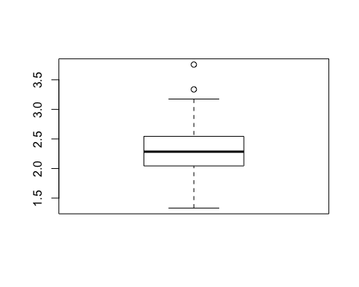

Of course we can do this for multiple variables.

### these are the proteins I'm grabbing 'CREB_N', 'ERK_N', 'JNK_N'  
  
###  
boxplot(data_cortex[, 'CREB_N'])

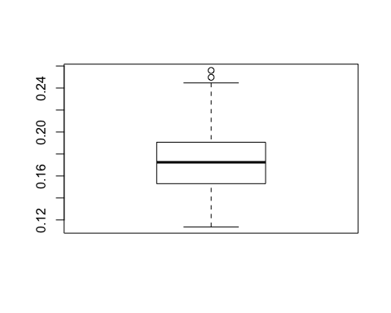

boxplot(data_cortex[, 'ERK_N'])

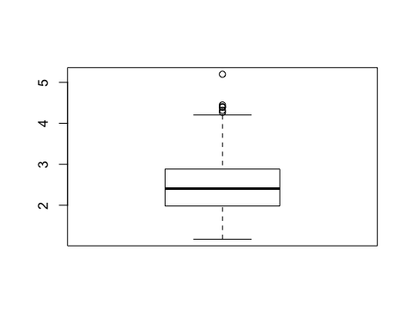

boxplot(data_cortex[, 'JNK_N'])

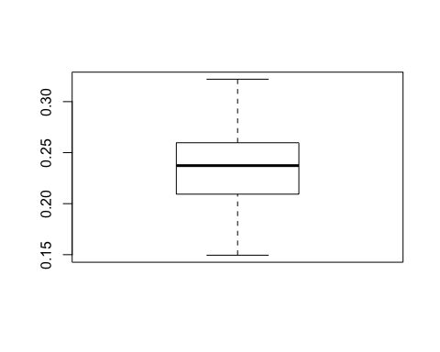

We can also get a list of the means for each of these variables

## grab the variables that we made the boxplots with.  
prots <- c('CREB_N', 'ERK_N', 'JNK_N')   
## grab those variables out of the data.frame and  
## reassign them to a new data.frame  
dc_prots <- data_cortex[,prots]  
  
## colMeans calculates the mean for each column  
kable(colMeans(dc_prots))

|  |  |
| --- | --- |
| CREB_N | 0.1731612 |
| ERK_N | 2.4823928 |
| JNK_N | 0.2350940 |

## standard deviation  
## the FUN part mean 'function', i.e. which function  
## you would like to apply to each column  
kable(sapply(dc_prots, FUN=sd))

|  |  |
| --- | --- |
| CREB_N | 0.0256362 |
| ERK_N | 0.6644644 |
| JNK_N | 0.0323462 |

kable(sapply(dc_prots, FUN=quantile))

|  |  |  |  |
| --- | --- | --- | --- |
|  | CREB_N | ERK_N | JNK_N |
| 0% | 0.1136364 | 1.169514 | 0.1494872 |
| 25% | 0.1530874 | 1.982082 | 0.2093339 |
| 50% | 0.1724507 | 2.406569 | 0.2372972 |
| 75% | 0.1906849 | 2.883884 | 0.2596802 |
| 100% | 0.2560119 | 5.198404 | 0.3219850 |

sapply stands for 'simple' + 'apply', which means roughly, 'apply this function to each column in my data.frame, then output the results in a simple format'. This is a nice function to use if you have to perform the same task over several variables. In fact the colMeans function is just a convinent wrapper for

kable(sapply(dc_prots, FUN=mean))

|  |  |
| --- | --- |
| CREB_N | 0.1731612 |
| ERK_N | 2.4823928 |
| JNK_N | 0.2350940 |

## Activity

* Grab the variables 'SOD1_N' , 'pGSK3B_N' , 'AcetylH3K9_N' from data_cortex.
* Create a boxplot for each.
* Note any possible outliers in each variable.
* Calculate the means, standard deviation, and Q1, Q3 or the 25th and 75th quantile. of each of the variables.